**Lab Exercise 7– Creating Multiple IAM Users in Terraform**

Objective: Learn how to use Terraform to create multiple IAM users with unique settings.

Prerequisites:

• Terraform installed on your machine.

• AWS CLI configured with the necessary credentials.

Steps:

1. Create a Terraform Directory: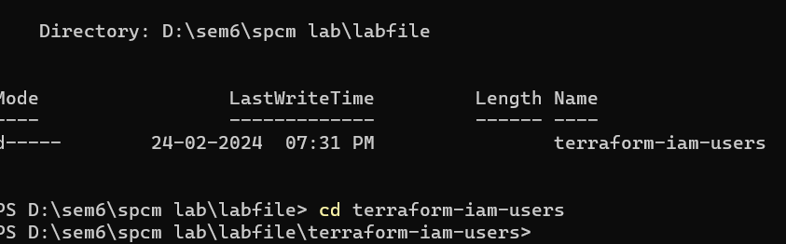

Create Terraform Configuration Files:

• Create a file named main.tf:

# main.tf

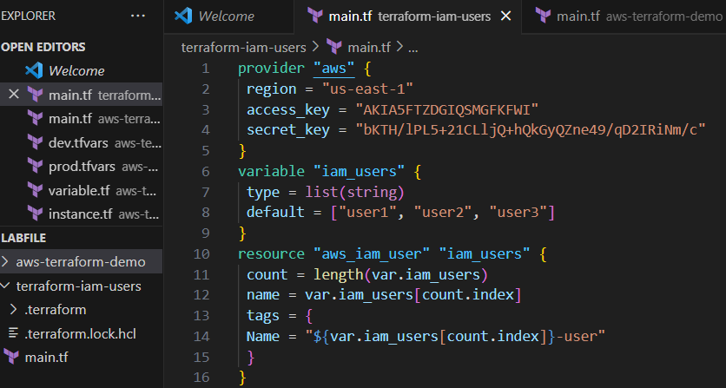

1. Initialize and Apply: Run the following Terraform commands to initialize and apply the configuration: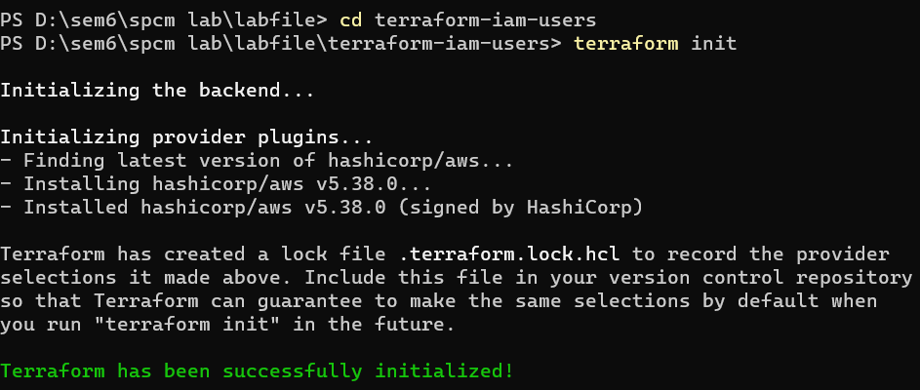

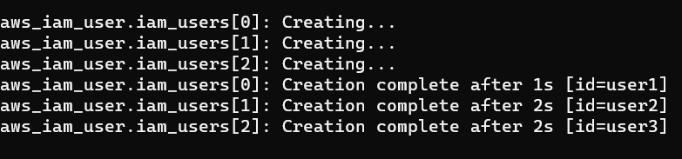

3.Verify Users in AWS Console:

• Log in to the AWS Management Console and navigate to the IAM service.

• Verify that the IAM users with the specified names and tags have been created.

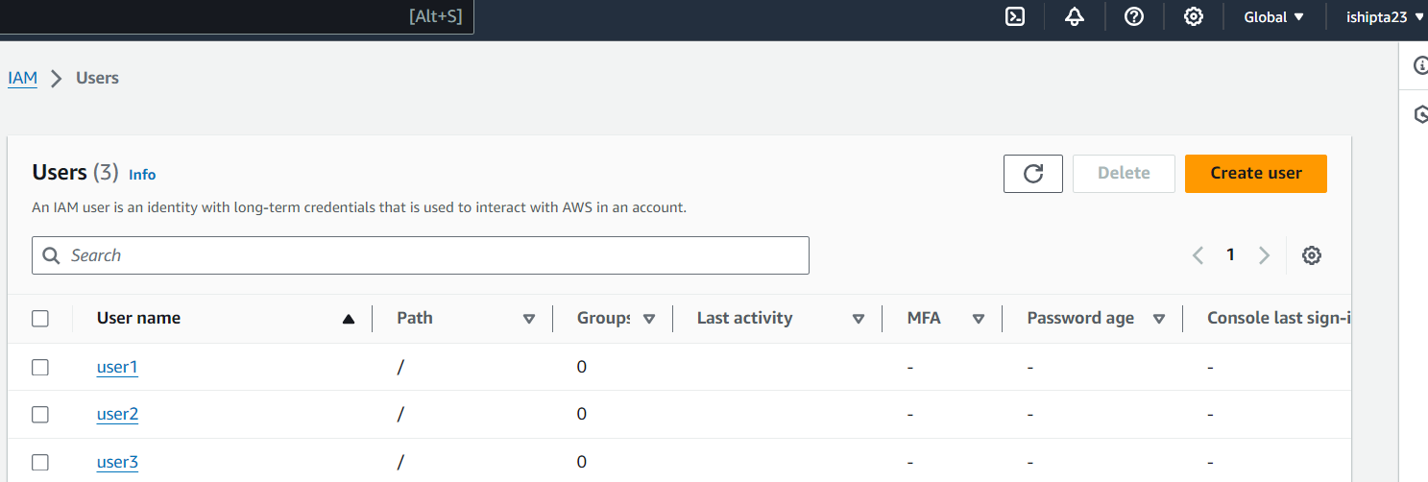

4.Clean Up:

• After testing, you can clean up the IAM users:

